H.T No
Regulations:
A19

Sreenidhi Institute of Science and Technology
(An Autonomous Institution)
Code No: 7M214 Date: 21-April-2022 (FN)

M.Tech I-Year II-Semester External Examination, April/May - 2022 (Supplementary)
ADVANCED FINITE ELEMENT ANALYSIS (TE)

Time: 3 Hours Max.Marks:70

Note: a) No additional answer sheets will be provided.
b) All sub-parts of a question must be answered at one place only, otherwise it will not be valued.
c) Missing data can be assumed suitably.

ANSWER ANY 5 OUT OF 8 QUESTIONS. EACH QUESTION CARRIES 14 MARKS.

Bloom's Cognitive Levels of Learning (BCLL)

Remember | L1 | Apply | L3 | Evaluate | L5
Understand | L2 | Analyze | L4 | Create | L6

 |  |  | BCLL | CO(s) | Marks
1. |  | Calculate displacements and stresses of the bar shown in the Fig. 1.  A₁ = 50 mm²  A₂ = 30 mm²  A₃ = 25 mm²  50KN  100 mm 100 mm 100 mm  Fig . 1 | L5 | CO1 | [14M]
2. |  | A beam of uniform rectangular cross section with width 1 cm and depth 2 cm and length 60 cm is subjected to a vertical concentrated load of 1000 N as shown in Fig: 2. If the beam is fixed at both ends. Develop the Global stiffness matrix (K). Take E = 10⁷ N/cm²  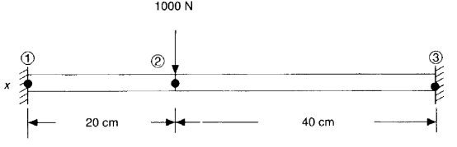 Fig: 2 | L4 | CO2 | [14M]
3. | a) | Derive and plot the shape functions of quadratic plane element. | L4 | CO3 | [7M]
 | b) | What is numerical integration? Taking a simple example and evaluate the integral value by gauss quadrature method considering one gauss point and two gauss points. Compare these results with the exact result. | L3 | CO3 | [7M]
4. |  | Consider a rectangular element as shown in Fig: 3. Assume plane stress condition, E = 30 x 10⁶ psi, ϑ = 0.3 and q = [0, 0, 0.002, 0.003, 0.006, 0.0032, 0, 0]^{T} in. Assess Jacobian Matrix and element strain displacement matrix [B].  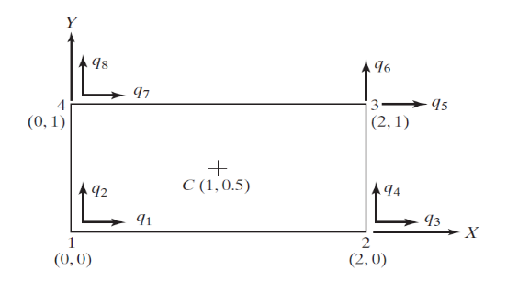 Fig: 3 | L5 | CO4 | [14M]
5. |  | Derive one dimensional steady state heat conduction equation and apply for one dimensional fin problem. Determine the temperature distribution in a straight fin of circular cross section. Use three one dimensional linear elements and assume that the tip is insulated. Diameter of fin is 1 cm, length is 6 cm, h = 0.6 W/cm² – ⁰C, ϕ∞=25⁰C and base temperature is ϕ₁=80⁰C. | L4 | CO5 | [14M]
6. | a) | Develop the element mass matrix for Truss element. | L4 | CO6 | [7M]
 | b) | Determine the Eigen values for the stepped bar shown in Fig: 4  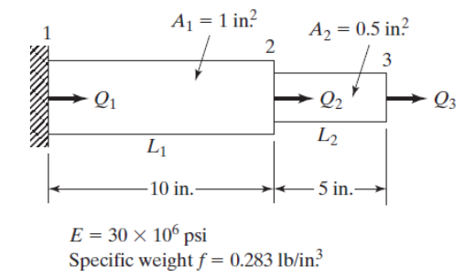 Fig: 4 | L5 | CO6 | [7M]
7. | a) | Write the basic steps involved in finite element analysis. | L1 | CO1 | [7M]
 | b) | Explain the principle of minimum potential energy. | L2 | CO2 | [7M]
8. | a) | Apply Gaussian Quadrature to obtain an exact value of the integral.  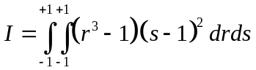 | L3 | CO4 | [5M]
 | b) | Discuss the Iso-parametic element and Axisymmetric analysis. | L2 | CO5 | [5M]
 | c) | Explain the Lumped Mass matrix. | L2 | CO6 | [4M]

-- 00 -- 00 –

